Selling Your Photography

By

Eric Zachary Ryder

Table of Contents

1 INTRODUCTION 1
2 BIOGRAPHY 6
3 Finding Your Style 11
4 PRINTING AND PRODUCTION 14
4.1 What Sizes and Why 14
4.2 Getting It Together 19
4.2.1 Cameras 19
4.2.2 Printers 20
4.2.3 Ink 21
4.2.4 Software 21
4.2.5 Paper 22
4.2.6 Signature Pens 23
4.2.7 Matting 23
4.2.8 Mounting Boards 24
4.2.9 Bags 25
4.2.10 Frames 26
4.2.11 Glass 26
4.2.12 Shipping 27
4.3 Mounting Your Image 28
4.4 Framing 29
5 MARKETING 101 30
5.1 Business Cards 30
5.2 Web Site 31
5.3 Bio 33
5.4 Rack Cards 35
Certificate of Authentication 37
5.5 Press Release 39
5.6 Where To Hang 41
5.7 Pricing 41
5.8 Racks 41
6 GENERAL TIPS 42
6.1 Transporting Your Work 42
6.2 Donating Your Work 42
7 APPENDIX A 43
7.1 List of Suppliers 43

INTRODUCTION

You have finally come to the conclusion that your photography stands the test of critical scrutiny and your friends and family are telling you that you have something you should try and sell. You’ve hemmed and hawed and shuffled your feet saying, “Aw shucks”, for too long now, and you’ve decided that perhaps – just perhaps – they might be on to something here and that heck, if other people can do it, why can’t you?
Well, you’re right, and I applaud your decision. My name is Eric Zachary Ryder and I am a seasoned photographer and consultant, by trade. Most likely like you, I have no “formal” training in photography, but I do sell my work for a solid profit through a permanent presence in a well-regarded gallery, and in several other venues. The definition I’ve seen most for what constitutes a “professional” photographer is that you make money selling your photography. By that definition, I qualify nicely.

My idea here is to share with you my lessons-learned during my journey. Even though I joined many online forums and asked lots of questions; visited galleries and talked to owners and other photographers; and did extensive reading of books on the subject, there were NO clear-cut answers to my questions.

This guide WILL give you the answers to questions you have, and questions you don’t even know to ask, at this point.
- Where can I sell my work?
- What sizes should I start with?
- What materials should I be using?
- Where do I get the materials?
- How do I market my work?
- How much money should I expect to make?
- Plus general tips for getting your work out there.

I spent close to $10,000 getting started, (not including my main camera and lens). A large amount of that was wasted because I didn’t understand the business. It was spent on the wrong frames, mats, glass, and etcetera. Everything that I could do wrong, I did - regardless of how much I researched. I also tried things that I shouldn’t have. Shortcuts, cheaper materials, and paying someone to do the work when I could have done it myself, if I knew how. You will easily save the paltry amount you paid for this guide, many times over. No hype. No BS. Just the facts- which is all you really want, isn’t it.

This guide is NOT meant to say this is the ONLY way you can make money selling your photography. Of course not. What this is, is a guide for the Average Joe Photographer out there who has taken some pictures he, or she, really thinks are “artsy” and worth framing and something that someone else might actually want to buy and hang on their wall. This is not meant for professional photographers. This is meant to help you become one. Its meant to get you motivated to getting the satisfaction of having your work admired and sold to willing buyers.
And lastly, this is real-world stuff. Below are pictures of my work on sale in the gallery I exhibit in, and have been doing so for a few years. You can visit my professional online site and see links to my other venues.

Less than six months before these pictures were taken, I had sold nothing and had no clue where to begin. The information you need is here to follow my path, solely because I know it works. All the framed pieces in these pictures are mine.

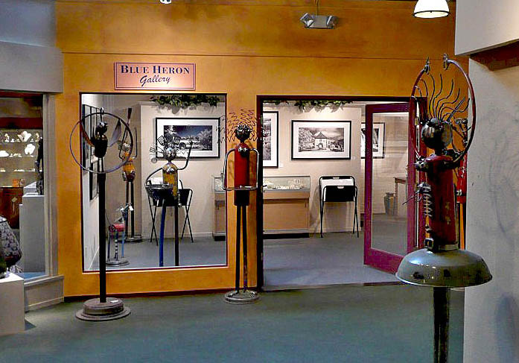

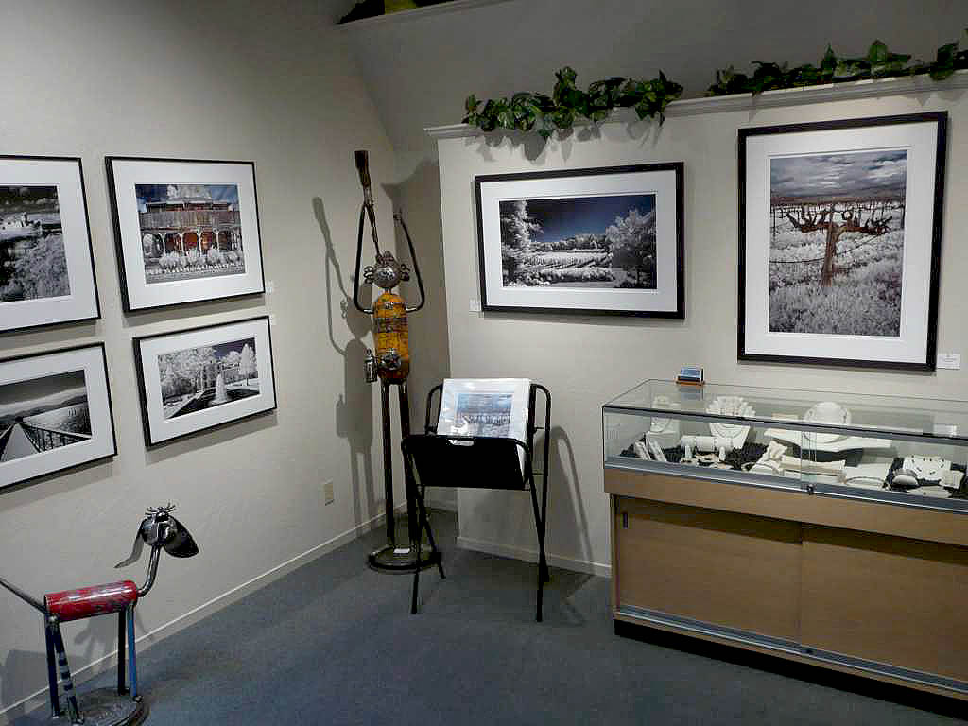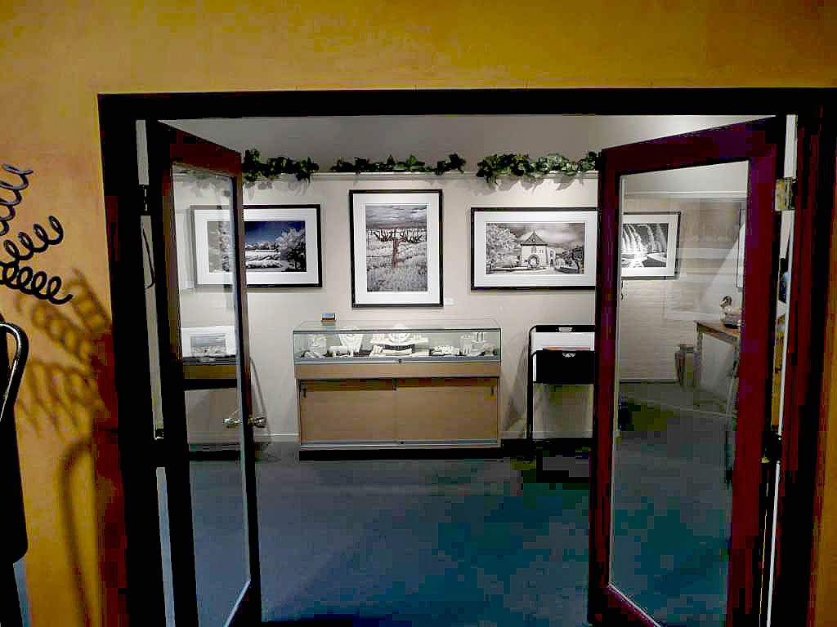

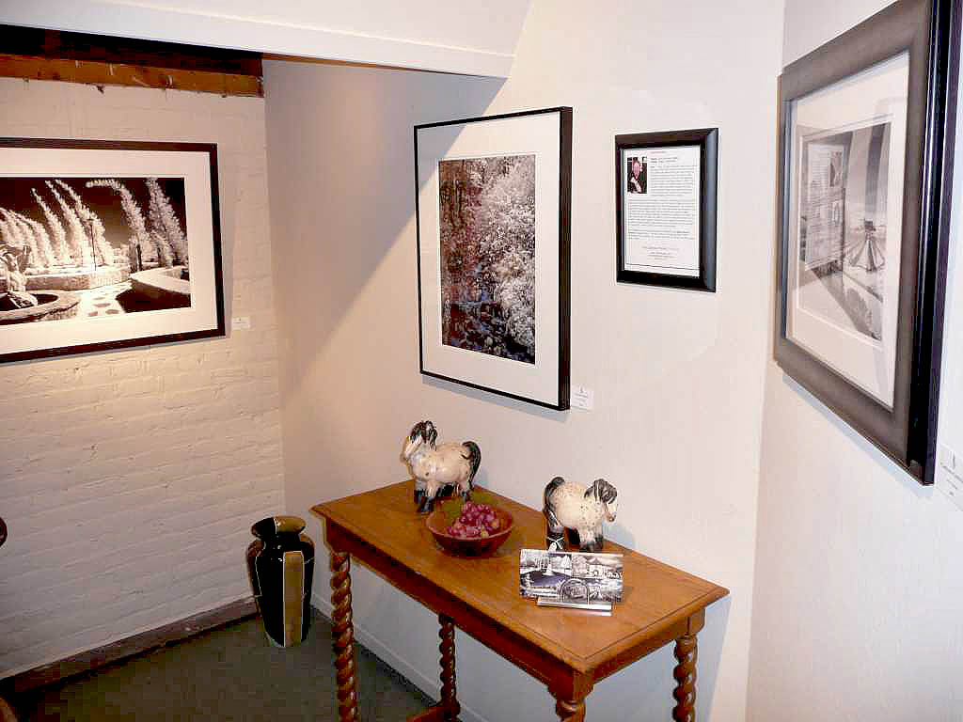

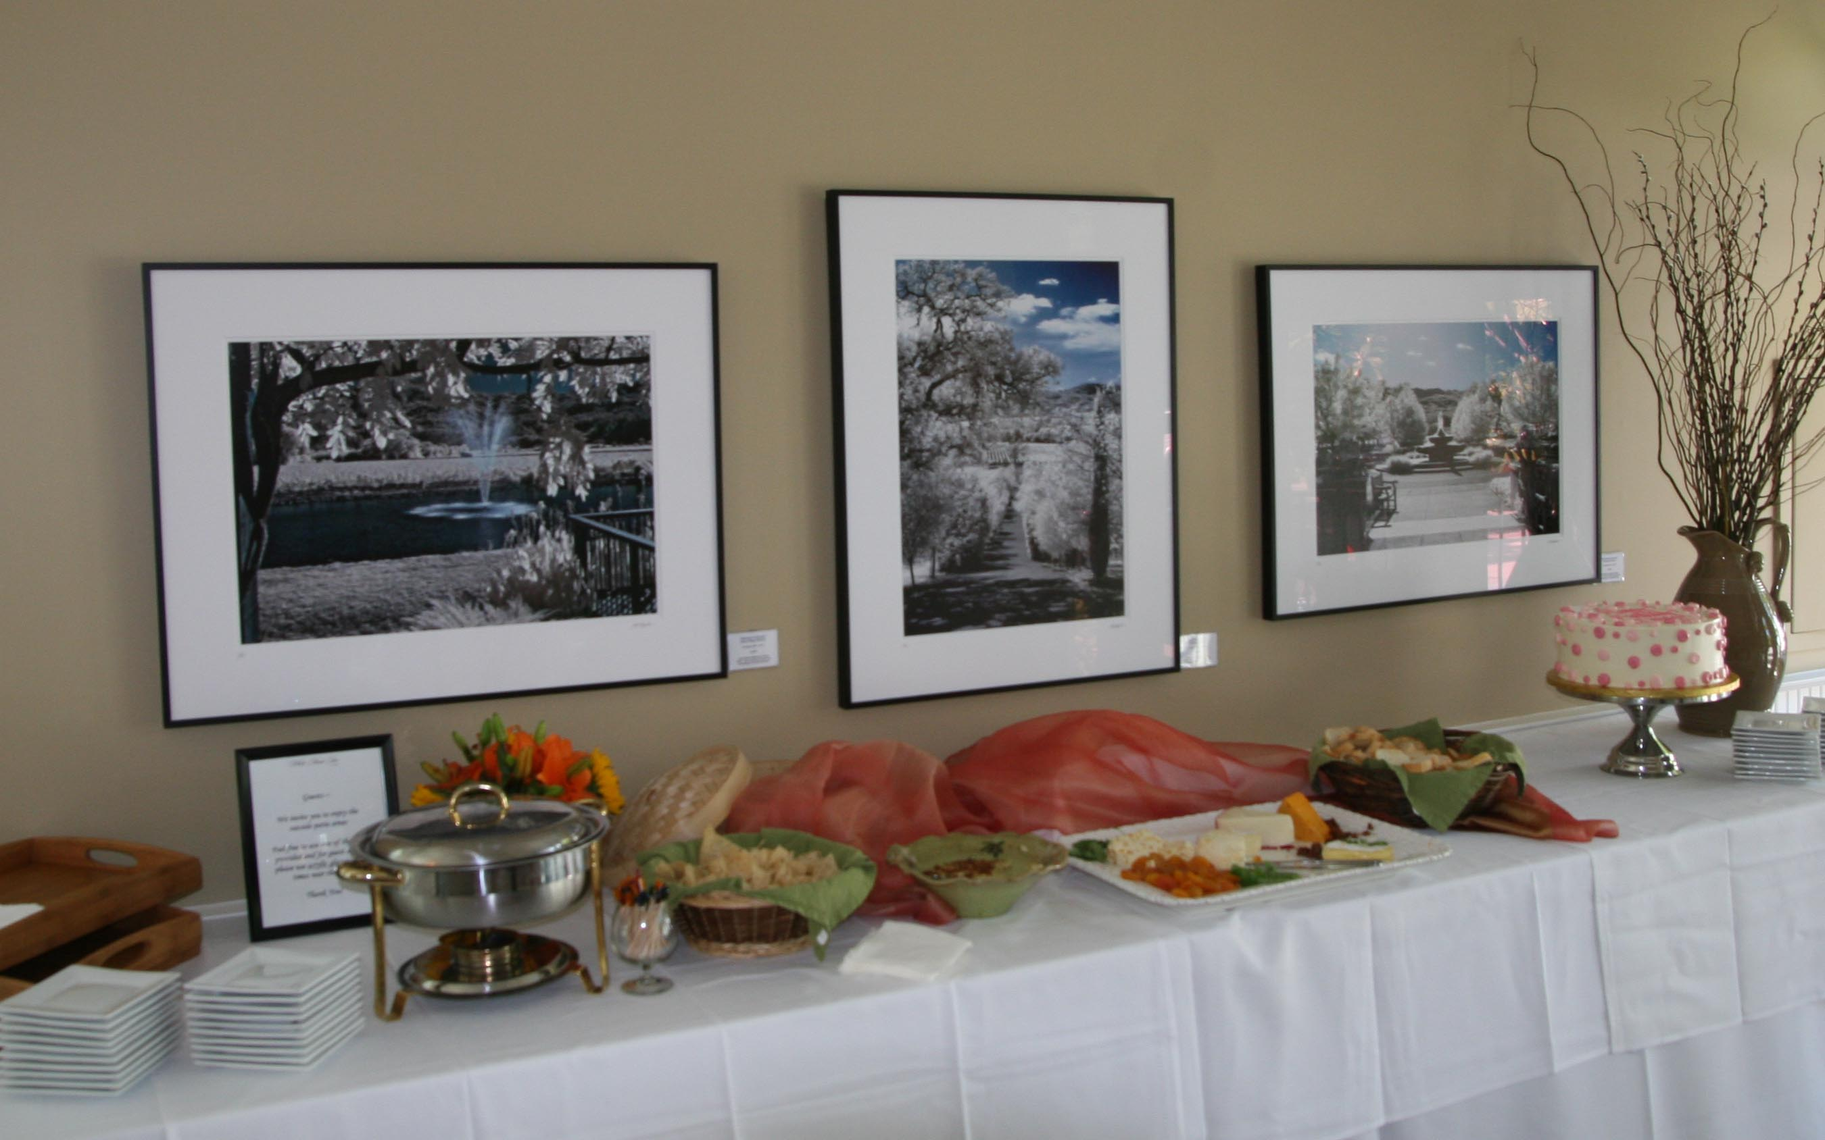

BIOGRAPHY

I got my first film camera when I was 20; a Canon AE-1. This was followed a few years later with the Canon A-1. I have always wanted to make money with photography, but didn’t know where to begin. I knew I had to do something… different. Let’s face it, there are a ton of photographers out there, and with the advent of digital photography, the numbers of creative people getting behind a camera are staggering. We can’t all make money.

Since I lived in New England at the time, I decided I would do a series on covered bridges, as my first foray into trying to sell my work. I dropped off my first roll of film at a professional photo finisher – versus the 1-Hour Photo places – because I thought I would get a better print. I was mistaken about that, to a degree, but the bonus was that the shop called me a few days later and said that they spotted one of my covered bridges pictures that they liked, and would I be interested in submitting it for their monthly contest. There was no entry fee, and the first prize was $50 worth of film and a free enlargement of the print, which was also to be displayed for one month in their front window. I, of course, agreed – and subsequently won the contest. It was thrilling! My first real stab at it, and I stumbled into some minor success. I got paid for my work. Granted, it was in film and not cash, but still…

A series of events in my life happened at that time which forced me to lay down the camera for several years, and when I picked it back up again, I had moved cross country to California, and was too busy in my career and newly found single life to get serious about my dream of becoming a professional photographer. I puttered around a bit, but never really dove in head-first.

Years and years went by and then suddenly, in the late 90’s, affordable digital cameras came on the market. I was instantly taken with the idea that I could take a picture and NOT have to wait an hour or a week to see the results. It made learning the craft so much quicker and easier. Unfortunately, I couldn’t afford a DSLR, and had to make do with smaller cameras and sensors, without the controls I needed and wanted in order to advance in my understanding of photography. I didn’t want to just take pictures; I wanted something creative and artsy at the end of the process. Something I could hang on my wall, or, even better, sell to someone else for their wall.

Over the next few years, I bought and played with almost 40 different digital cameras. I’d buy the latest and greatest and then sell it on eBay for a loss sometimes just a few months later. But the cameras were getting cheaper, and the performance and quality improving, so the net loss was something I could live with.

During this time, I honed my skills and understanding of digital photography. I spent countless hours on photo forums and camera review sites. I looked at thousands of photos and visited photography galleries and arts and crafts fairs everywhere I went. My images were getting better and better, but I still wasn’t satisfied that I had something truly marketable. As I’ve said, there are zillions of extremely creative and artistic photographers out there that keep me quite humble – and realistic. And insecure. How could I compete with so many talented people?

I created a web site to showcase my work in a fairly professional way. I bought templates for the sites and customized them for my own look. I was building a nice little portfolio of color and a few black and white images, but no idea how to sell them. I looked into different avenues, such as selling stock photos, but the competition was incredibly fierce; I would be one of many thousands of photos- most of which are graphic art related, for use in advertising or marketing material. My photos were just “nice”.

One day I spotted a photograph done with an infrared filter attached. It was surreal and fantastic and I was drawn to it immediately. I had seen a few of these before, but there was something about this one that screamed “fine art”. I believe I was ready to see this picture at that moment. I knew right away that this was the ticket for me.
I started doing research on infrared photography and learned all I could about it. I decided to take the plunge, and bought a small, cheap, digital camera – a Sony DSC-P200 – and had it professionally modified for infrared. It would no longer be able to take color pictures, but the camera itself was only $300, so the total price tag of $600 was worth the risk, to me. It was a 7.2mp camera with a good lens. Pictures I’ve gotten with that camera have made me many times over what I paid for it.

I soon realized that I needed more resolution, for bigger images. I graduated to a Canon 30D and had it modified for infrared-only. That was a much bigger expense, and I was taking a bigger risk. At this point, I had not actually sold anything to anyone, but I thought a DSLR was going to give me that extra sharpness, resolution, and image quality I felt I needed to play in the big leagues. I was right, though I still like to think about the few pictures from that little Sony that eventually made money and are still some of my favorite shots.

Soon, I was building a portfolio of my best infrared shots, and decided to get more serious about my online presence. I joined SmugMug, signing up for their Pro account. I spent many months working with their team to create an interesting site – www.ticket2ryder.com – that I could use to sell my images. I sat back and waited for the money to roll in. I sold nothing. Zero. For almost a year. It was disheartening, and I realized I really needed to get proactive about this. I created business cards with one of my images on the front. I started talking to local gallery owners about my work and giving them my card. Nothing happened until one day I was sitting at a bar eating lunch and started talking to a woman next to me. One thing led to another and I gave her my card. I mentioned the name of the winery who’s picture I had used for the front, and it turned out she knew the owners of the winery. She called them immediately- while I was sitting there- and told them she was looking at a great picture of their place and they should check out my online gallery. Two days later, the marketing director for the winery- one of the main wineries in Napa Valley- sent me an email asking me if I would be interested in selling my images in their gift shop. She asked me to bring some samples of my printed work by the winery, and we sent up a date and time a week and a half away.

I was thrilled, of course, but also completely unprepared. What would I show them? How big? Framed? Matted? What kind of frames? What color and type of mats? How much would I charge? Where do I get supplies? How do I print them? What kind of paper? What are the RULES here???

The short version of the story is that I figured out what to do and was able to sell them $1,300 worth of my images, which they paid for up front and sold in their gift shop. Months later, they had a two-month exhibit of my work, with a nice Bio on their web site and a “meet the artist” event, (in fact, you can still see one of my pieces for sale on their web site at www.peju.com. It was all very heady stuff.

Before I knew it, I was in a gallery selling my work, and then a second gallery. And then several other venues. All of this within one year of meeting the woman at that bar.

What you’ll find here is the mistakes I made, and how not to make them yourself. The money I spent was only because it seemed there was no one that could- or perhaps would- help me. Competition is fierce, and knowledge is the key that people keep close to the vest.

Finding Your Style

The most important thing in being able to sell your work is to have something either unique or very good for its genre. Like incredibly picturesque landscapes of exotic places, or lightning strikes, or incredible sunsets. Along those lines. Unfortunately, that kind of photography typically requires top-end cameras and lenses. You’re looking at $15,000, minimum, just to get started.

What I realized early on was that in order to make money at this game, you have to sell “fine art”. Pictures of dogs and cats and flowers aren’t going to do that – unless you do something very unique with the images. If you don’t have $15,000 for equipment, you can try using Photoshop, or other programs, to turn your average photo into something more interesting – but you must be careful not to over-do digitally enhancing your images.

An example of something unique would be a black and white photograph with one object in the picture in color, such as blue jeans, (in black and white they would be black), or a red hat. You see this kind of stuff, but not too much that it’s overdone. One woman I saw at an Arts and Crafts fair in Portland took pictures of the seaside towns and worked on them in Photoshop to give them a stick-figure look. They looked like drawings and not photos. Very effective. But it could that as soon as someone knows they were “photoshopped”, it takes the wind out of it. They may feel tricked. It doesn’t take away from the fact that they are great looking images, and still take skill in composition and Photoshop, as well as the right equipment to get the shot to begin with.

Art buyers don’t like anything that comes too easy. They’re paying for something they can’t do themselves. The attitude – wrong or right – is that if it just takes a few button clicks in some software program, then it isn’t art. They want to see silver halide with large format, high resolution, images printed by hand and with only a few of the same image ever put to paper. If you’re going to overcome that reaction, you better have something convincing or very hard to achieve. On the other hand, some people just like a nice image and accept it for what its worth; something that will look good on their wall, and to hell with how it came about. Those people tend not to want to spend a lot of money for their art, though.

You need to have a good eye; to be able to recognize what’s good and what’s not. This is a difficult thing to do, and you need the help and opinion of friends, family, and professionals to make that determination. Join photography forums, such as www.dpreview.com. People there are more than willing to help you. I’ve found them to be an invaluable, 24 hour a day, worldwide, resource for getting the answers you need. Having said that, I still couldn’t get all of my sales-related questions answered to my satisfaction. I had to learn the hard way. But, forums are a fantastic resource for testing the waters on the commercial marketability of your images.

The other things to think about are learning some of the rules of composition, like the “rule of thirds”, and other techniques for drawing the viewer into the picture or having them look at something ordinary in a different way. This guide is not about teaching those things. There is plenty of material out there on taking good photographs. If you’re reading this, you probably know your images are appealing to you and to others, and just need to get your foot in the door.

To summarize; what is important is having something different. Something that few others are doing, or doing something everyone else is doing in a different way.

PRINTING AND PRODUCTION

This is the meat of the matter, here. This is where I found the hardest time getting straight answers to what one would think were simple questions. Or, better yet, not knowing what questions to even begin asking. It’s funny how you don’t think of “production” when you think of selling your work, but its extremely important. It’s not just having nice images; it’s presenting them in a way that’s appealing, yet as inexpensive as you can make them. It’s a fine line there when you start realizing how much materials cost and how much money the various venues will be taking right off the top – before your costs.

What Sizes and Why

When I got my first meeting with a local winery interested in selling my work, I was a bit panicked. I had no idea what to show them, or how. I didn’t own a big printer. I decided to use the SmugMug online service to print a few images at a large size, and then get them framed at a local frame shop. But after looking at the costs for framing, I was halted in my tracks. A decent sized print would run me $300 for a quality frame job, plus the cost of the print.

I ended up doing some online research and found a place called PictureFrames.com. I chose them because they were turn-key; I could upload my image, frame it online, with different color mats and play with the sizes and styles of frames until I got something that looked good, and they did everything for me. The picture was delivered complete; printed on quality acid free paper, mounted, matted, framed, wired, and fronted with Plexiglas. The only problem was that they weren’t signed and I had to undo them, sign them, and then have the local frame shop button them back up again – for about $15 apiece. Added to the $150 each they cost me.

At the end of the day, I spent $500 on three complete frames. But I wasn’t done, yet. The prints came out bad and I had to have them redone. The frames weren’t the color they looked to be online. The mats were also not the color I expected. It was a fiasco, and I had to push my meeting out by almost two weeks before I got everything right.

In the meantime, I also knew that I had to bring something to the winery gift shop that they could sell for less than a fully framed piece. I looked around at other gift stores and galleries and found that 16 x 20 and 8 x 10 were common sizes just about everywhere. They all had white mats and were in cellophane “bags”, or “sleeves”. These wrapped the image fairly tightly and protected them from dirt and fingerprints. The job now was to figure out how to mount and mat the pictures. And print them, of course.

Part of the problem was that I couldn’t use the online frame shop for just printing, mounting, matting, and wrapping the result in cellophane. They were mainly in the business of selling frames. I tried working out a deal with them, but it became too cost-prohibitive to be a viable solution for me. The winery gift store people would be marking up the final product by 50%, and the going price was to be $150. I knew another local winery that sold similar prints for $175. I also knew yet another site sold them for $65. Of course, I failed to mention the $65 place when talking to the Marketing Director, and convinced her that they could price them at $150.

Initially, the complete cost of printing and packaging a 16 x 20 was about $20. If I charged $65, the gift shop would get $32.50 and I would get $32.50. Minus the $20 and I was only making $12.50 each. That seemed like a long way from $65. In hindsight, it might have been better to sell them at $65, because in a gift shop environment, it was tough to move them at $150. Though they did sell, and I made $55 on each. Paid for up front, which is not the typical arrangement; most stores will only do that kind of thing on consignment, where you put up the money to package the things and they give you your share after they sell.

The Marketing Director also wanted a smaller size, and was happy with 8 x 10. The problem was that they didn’t want to charge more than $30 for them. Since they cost me about $10 each to make, I only made $5 each on them. It got to be that it wasn’t worth the effort and I stopped doing 8 x 10’s altogether.

Eventually, I ended up figuring out how to get my costs down to about $15 for a 16 x 20, and they now sell for $150, or 2 for $250, in the gallery and other venues. A gallery is the best place to sell your work for top dollar. Gift stores and the like will force you to print cheaper and use cheaper mats and mounting boards. And the end product will look… cheap. If you’re putting your name on it, you might want to think about what that means to your reputation down the road. You can’t start selling cheap material and then try to break into the fine art, bigger money, world. But you can go the other way, (see Thomas Kinkade, for example).

For your larger, framed, pieces, I’ve found that 24 x 29 and 28 x 18 are good sizes. Why? Because you have to take paper and printer size into account. 17 x 22 is a common paper size, and about the largest you can do on a high quality desktop printer. You’re restricted by the 22” side, minus an inch for a working border. That leaves 21”. I find that a 4” mat is pleasing, so add 8 inches to your 21 and you get 29. 24 minus 8 is 16 – just one inch shy of the 17” width of the paper. For my work, I found that landscapes tend to fit in the 28 x 18 size – again, restricted by the 22” height of the paper. I could have gone 29, of course, but the extra inch means I had to stretch the image an inch more than I wanted to, or have an extra ½ inch of mat on the top and bottom, and I prefer the mat to be the same all around, if I can help it. Though some people like, or wouldn’t even notice, the difference. Personal preference, and all that.

The beauty about these two sizes is that you can fit most of your work into them and you can print them on a desktop printer with paper that comes in a sheet and not on a roll. That, in turn, means you can mount the image yourself and save a fair amount of time and money – about $25 in dry mounting costs. You have to be careful, however, because you are at the limits of what you can hang, or corner, mount without worrying about waviness in the print. Anything over these size prints will likely want to be dry mounted.

For the biggest sizes, I go with 30 x 38 and 40 x 27. This time, the reason is frame size and glass size. The largest frame size you can get through the mail is 40” on one side. Anything else you have to have done at a framery – for much higher cost. If you don’t own the gallery, you need to be frugal on framing costs. Galleries also take 50% before your expenses.

Glass size, as well, needs to be considered. Museum glass typically comes in 32 x 40 or 36 x 48 sheets. The more of the glass you can use, the better. More on glass later.

For these larger pieces, it’s best to have a good 5” mat. The frame will swallow up about a ¼” on all sides, so it’s really 4 ¾” anyway. Trust me, it makes a big difference. I once did a slew of prints, had them dry mounted and matted, and then framed them only to realize they looked stupid because the mat was too small. I ended up either giving them away or modifying the mat, if I could, (because some were stuck too strongly to the print and getting them off ruined either the print or the mat). Big (expensive) lesson learned there.

The important thing here is to find “standard” sizes you can fit your portrait and landscape images into, and make your images conform. This way you can buy mats and mounting boards in bulk and save a lot of money. Keep an eye on the realities of sizing. You’ll be glad you did.

Getting It Together

Here we will talk about the hardware and software, as it were, of capturing, printing, and production.

Cameras

This guide is not intended to talk in depth about how you capture your image, but a few thoughts on the realities of printing large images is worth spending time on. Getting good looking prints to look good over 8 x 10 means you need high resolution. That means bigger sensors and good lenses and cameras that offer RAW capture. And the necessary software to work the RAW image. It’s possible to use programs such as Genuine Fractals to boost the resolution, but I’ve found they don’t help more than a little. The importance of shooting in the RAW format can’t be underestimated. You will see a big difference when you print out something from a large RAW, (acutlaly .tif), file versus a JPEG compressed file. Sharpness and detail are retained and compression artifacts not magnified, as with JPEG prints. I resisted using RAW for a long time. Now I wonder what I was thinking. Get a big hard drive. You’re gonna need it.

As for cameras themselves, there are plenty to choose from. A DSLR, of course, is the best way to go, but my main reason for including this section is to stress one thing: Get good glass. Pro lenses are very, very, expensive, but in the end, it’s what you have that everyone else doesn’t have. Except the pro’s, of course. Buy them used, or find a good size that works for you and is reasonably priced. Personally, I have a 17-40mm f2.8 Canon L series lens. This is a pro lens that covers most of my needs. It’s the sharpest lens I have, as well. I have a bunch of other excellent lenses, but there really is a difference when you get the good stuff. My only other advice here is to send it to the manufacturer with your camera and have the lens calibrated for you camera. It doesn’t cost anything but shipping and can make a big difference. Not all lenses are alike – even pro lenses. There is such a thing as getting a “bad lens”. It happens more than not, in my experience.

Having said all this, as I mentioned earlier, I have gotten great, large, prints from a tiny pocket camera that had a good lens and 7.2mp. A tripod, a calm wind, and a self-timer can do wonders.

But, you already have good images and probably know how to take them or you wouldn’t have bought this guide, so onward and upward.

Printers

The industry standard seems to be Epson when it comes to professional printing. Not that there aren’t plenty of options, but… it’s hard to deny the quality of their products; ink, paper, and printer. I have a 3800 desktop and a floor-standing 7800. The 3800 cost me $1,300 and the 7800 cost $2,000. Both were on sale at the time. The 3800 can print 17 inches wide by 22 inches high – though, apparently, you can go up to 35 inches. I haven’t seen paper for that size, though. After 17 x 22 you have to go to a roll. The 7800 is 24 inches wide and uses a roll that’s 100 feet long. Given that, my prints are never more than 23 inches in the shortest direction. Anything printed from this printer has to be dry mounted because of the curl from the roll.

Ink

Using archival quality ink is very important. You don’t want your masterpiece – the print someone just bought for $800 – to fade away a few years later. I use pigment-based Epson UltraChrome K3™ ink. Guaranteed not to fade for 200 years, or so, as long as the print is not subject to long times in direct sunlight.

As you may already know, ink is very, very, expensive. These printers have 8 or 9 cartridges. Each cartridge for the 7800, for example, costs in the $80 range for the most economical, large, size. You will make mistakes and have to reprint. Possibly many times. It’s a factor. I figure about $15.00 to print one large print, including paper, on the 7800; maybe $10.00 for the 3800.

Software

Here again, this guide isn’t meant to talk about getting the most out of your image, but it’s worth mentioning the use of resolution enhancers, such as Genuine Fractals, and noise removers, such as Noise Ninja. These are downloadable software products that can help spruce up an image and have been highly useful to me. More so Noise Ninja, for my particular work, but Genuine Fractals is highly regarded. Check out the forums, like dpreview.com, for more information on different tools available. Photoshop, of course, is the standard, and worth every penny.

Paper

Paper is an important decision in printing high-quality fine art images. For the Average Joe Photogapher, this means acid free and something glossy but not too smooth. The perfect paper, in my opinion, is something called Epson Ultra Premium Photo Paper, Luster. It has a smooth pebble-like finish and has great contrast. I’ve also used paper from Red River, which is very similar, though not as “deep”. It’s a bit cheaper and good, I think, for 16 x 20’s, especially. Anything larger and I want to use the Epson paper.

Of course, there are a nice variety of paper that you can use – including canvas, velvet, rag, semi-matte, and etcetera. Online places typically offer a choice of these different papers. You may find they enhance your image.

Signature Pens

One of the most daunting things I faced was trying to find a pen to sign my work with. It had to be acid-free, yet able to write on the image itself. I highly resisted the notion of messing up the visual aesthetics of the piece by scrawling my name on the mat. I thought I could discretely sign the image itself. This led to trying a host of pens- most of which leaked and dried up or just scratched the image. The signature was too thin or too thick. I even tried using “invisible” ink and giving away a small pocket black light to shine on the mat so you could read the name. (I thought that was clever, but it didn’t seem to take off).

Eventually, I went with the tried and true pencil, and signed the mat like everyone else. Or most people, anyway. I also use a Faber Castell Pitt Artist Pen for my 16 x 20’s. It’s acid-free ink and draws a nice thin line. You can get it at ArtSuppliesOnline.com.

A good pen for signing the image itself is a Sharpie Paint. It comes in many colors and is available here at: ArtSuppliesOnline.com.

Matting

The biggest challenge I had was to figure out what style and color mat to use – or whether to use one at all. I quickly determined that most fine art prints use a mat to emphasize and create distance from the surrounding frame and wall. They remove the distraction and help the viewer focus on the image. The next question was how wide the mat should be all around the image. The temptation is to go with something thinner than thicker, but that notion should be squelched. There is such a thing as too big, but if the image is of a decent size – over 16 x 20 – then the mat should be over 4 inches. For a 5 x 7 print, a 1.5” width adds up to an 8 x 10 mat/frame. Perfect. And it looks good. To work backwards from a 16 x 20, you want at least a 3” width. That means your image should be no larger than 12 x 14.

The type of mat should be acid-free, of course, and preferably a double-mat with a 1.4” set back for 16 x 20” matted prints. This will give a beautiful look and help justify the big price tag on your piece. I, personally, use Documounts.com. For my work, I think Alpharag Solid Core, 4-Ply, Pure White Mat, with a ¼” set back is best. It’s the brightest, cleanest, look. These mats are about $10, (in a quantity of 25), plus tax and shipping.

Mounting Boards

For 8 x 10’s I’ve found the best thing to use is the 3/16 inch self-adhesive acid-free foam core board. I print my images on 8 x 10 Epson Ultra Premium Photo Paper, Luster, and use an exacto knife to cut off the corners. I then take the 8 x 10 board and cut the corners of the adhesive and peel them off, leaving just sticky corners, in effect. I then sandwich the image between the board and mat and square it off. The mat sticks to the board and holds everything in place and centered. See Section 4.3 Mounting Your Image for a pictorial. These boards cost about $1.10 plus tax and shipping, with a quantity of 25. The more the cheaper.

For 16 x 20’s, I use the non-adhesive 3/16” foam core board. It’s thick, yet lightweight, and offers more support and fills out the cellophane bags better. They feel substantial, and add dimension to the piece. In other words, it makes the buyer feel like they’re getting something for their money. These run about $2.50 plus tax and shipping for a batch of 25.

Bags

In order to sell 16 x 20’s and 8 x 10’s, you need to put them in clear protective sleeves, or “bags”. (I don’t know why, but I have a hard time thinking of them as bags, but that’s what they’re typically called). Finding the right bags was a real challenge, and I wasted time and money on bags that weren’t as clear as I expected, or were too… baggy. I also found that the 8 x 10 bags were too tight for the 3/16” foam core, and never did find any that did fit. I ended up moving to thinner boards, but then abandoned 8 x 10’s altogether.

The best bags I’ve found are Krystal Seal brand. They’re cellophane, so they’re very clear and strong. There are many places online that sell them. I go for the discount size of 250. Think positive; you’ll need them!

Frames

I found that if you want to sell in a gallery and make a fairly decent return on your efforts, you cannot use high-priced fancy frames. This is one place you can save real money without losing the aesthetic appeal. I spent an enormous amount of time and money trying to find the right frame style for my work. Online framers sell some decent frames for a discount, but a lot of them are cheaply made and get chipped very easily. To be on the safe side, I recommend – and use – metal frames. They’re cheap, strong, come in colors, and with the right finish, look very much like wood. I get mine from Documounts.com. The back loading model comes pre-assembled, up to 24” x 24” for $10-12 plus tax and shipping. That’s a fantastic price. For larger pieces, you need to assemble the frame yourself, but it’s simple. It takes about 15-20 minutes to fully assemble the frame, install the glass and mounted photo, and string the hanging wire. Pre-assembled is much faster, of course, but you can’t use a hanging wire. You have to use the serrated mounting tab it comes with. No big deal.

Glass

This is another place where you can shine or you can go cheap. If you’re in a gallery trying to charge $1,300 for your framed piece, the buyer is going to expect some quality, non reflective, glass in front. Plexiglas is a nightmare for fingerprints, scratches, and most irritatingly; static. The static will attract everything in the air and is a pain to clean. My first pieces all used wood frames with Plexiglas, and I had to re-do half of them because little pieces of lint or wood chips would get in between the glass and the mat, making the mat look less than pristine. It drove me crazy.

Finally, I decided on museum glass. It’s very, very, expensive, but unlike non-reflective Plexiglas, it doesn’t take away from your image and is really remarkable in keeping the glare away. Under bright light you can’t even tell there’s glass there. Non-reflective Plexiglas gives your image a 3-D baseball card look.

Like the builder of my house said; put the money in doors and windows and you will get it back exponentially. Good glass is also a selling point and helps justify a much higher price.

You can only get museum glass at good frame shops. Be prepared to pay $150 for a large piece.

Shipping

For those magical times when the customer wants just a print – unmounted and unframed – you need to have a way to ship it to them. I use heavty-duty cardboard tubes that are two feet long and 4” in diameter. I wrap the print in plastic, careful not to put any creases or kinks in the image, then carefully roll it up and slide it into the tube. These tubes can be gotten at several places online. I get mine from Uline.com.

Mounting Your Image

When I first started out, I was afraid that mounting a photo to a board and centering it within a mat window would be difficult without some sort of “machine” or draftsman’s table, or something. I thought I’d have to measure everything out and trying to center it would drive me crazy, and I just didn’t have the time or patience – or tools - to do it. I found virtually no help online.

My first stab at it was, I thought, pretty clever. Use self-adhesive foam core mounting boards of the same size as the paper I wanted to use – 8 x 10 and 16 x 20. Anything over 16 x 20 I would dry mount anyway. I would peel the backing off and then just pop the print on there, already centered because it was the same size as the board, and the printer centered the image for me.

After several trashed prints, I realized it was pretty difficult to get the print straight on the sticky board in one shot. Attempts to peel it off and try again often ruined the print. Plus there was no way to get the mat to stick to the board. My thought was to glue the mat to the print. Bad idea.

At the end of the day, I used a razor blade and cut the paper on top of the adhesive, and also cut triangles out of each side. I then cut the corners off the print, but didn’t cut triangles off the sides of the print. So the side triangles held the print to the mounting board, and the corners held the mat, sandwiching the print. It worked well, but I was wasting paper, the adhesive boards cost more, and it was a lot of hassle to do the cutting.

In the end, the gallery owner showed me the way. I now print my 16 x 20’s on 11” x 17” paper, (since the image itself is no larger than 10 x 14), and use “sandbag” weights made especially for holding the print in place after you center the image under the mat window and then apply “corners” to fasten the print to the mounting board. A few runs with the tape gun around the print, and then you affix the mat and call it good.

Below is a pictorial of the process.

Framing

Building your own wood frames is not something I ever want to tackle, as it takes the right set of tools and buying frame stock in bulk. It’s not difficult, but for the Average Joe Photographer who just wants to make a little money on the side selling their photography, I would stick with wither cheap black wood frames, or even cheaper black metal frames. See Section 4.2.10 for a link to where I’ve found excellent metal frames for a fraction what wood would cost, (links are also in the Appendix). The metal frames, however, do require assembly, and they don’t give you much instruction, if any. Below is a pictorial showing the assembly of a metal frame.

MARKETING 101

Before you can get started selling your work, you need to be prepared to show your work in a professional manner. Business cards and a website are your tools of the trade.

Business Cards

I use Vistaprint.com for my cards. I can upload my image and drop text on top of the picture and also add text to the plain back of the card. Or even have an image on both sides. They have all the tools you need on their site, and it’s extremely simple to design your own card. You can have something highly professional looking in an hour, at the most.

Pick an image that is striking and representative of most of your work. If you do mostly color, don’t have a black and white image on the card. Perhaps that goes without saying.

Also, design a logo, of sorts, which makes your card more appealing and makes you appear professional. Here is what my cards look like, ($57 for 250). Simple, yet effective. Sort of like, “Ralph Lauren | Polo”.

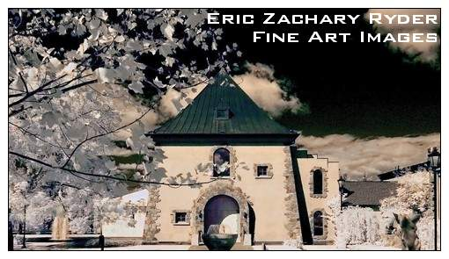
Add your web site link, email address, and phone number. Print them glossy on the picture side, and matte on the back. A box of 250 should cost no more than $70. You can get a card for half that, but don’t go cheap here. You want glossy and you want double-sided.

Web Site

There are a few inexpensive ways I’d recommend getting an online presence that looks professional.

- Do your own site, using a template
- Sign up for online photo sharing services and design a site there

Templates are plentiful online. I’ve used several from 4templates.com. I’ve spent no more than $65, and typically less than that, and I’ve also gotten totally free ones that worked just fine, though not as fancy.

If you buy a template, you’ll need to do a little work, and you’ll need a few tools. At minimum, you can use Word to edit the html files to look the way you like, inserting your pictures wherever you want. It is, however, cumbersome and can take a lot of trial and error to get it to look right. You can also use expensive tools like Adobe Dreamweaver, but for my money, the best way to go is using an online service.

Online services such as SmugMug will give you a choice of themes you can use to showcase your work. The “Pro” account charges a yearly fee of around $150, but you can get away with a regular account for something like $30/year. The Pro account typically offers more tools and more support for designing a truly interesting site with a professional, unique, user interface. See my site at www.ticket2ryder.com for an example. You can build these sites very quickly if you stick with the basics – literally in a few hours. The more professional the site, the longer it will take to build. But, you can start basic and add features over time.

Bio

People become more interested in buying art if they know something about the artist. They become even more so when they meet the artist, but because you can’t always be there, a good Bio – printed and framed and positioned near your work – is the next best thing. Especially if you don’t have rack cards for the would-be customer to peruse. Here’s an example:

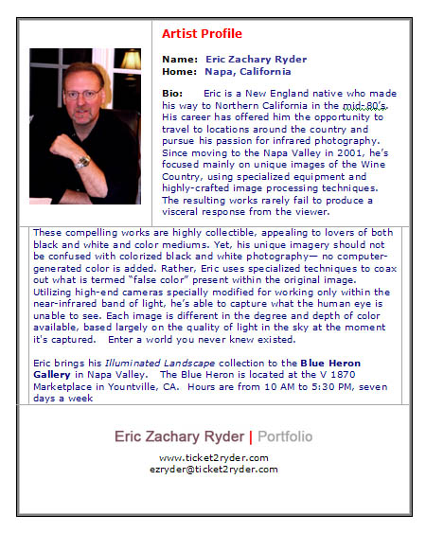

Rack Cards

Rack cards are a great take-away for visitors to the gallery or exhibitions you might be showing at. They are a standard size – 8 ¼” x 3 ¾” – and you can showcase more than one piece on the front and offer a Bio on the back. The card below was done on Vistaprint.com. A box of 500 was roughly $114, including tax and shipping. You need something like Photoshop to stitch together your images, but it’s very simple to do.

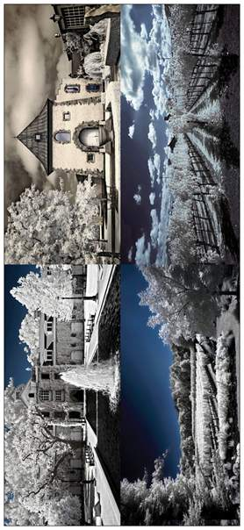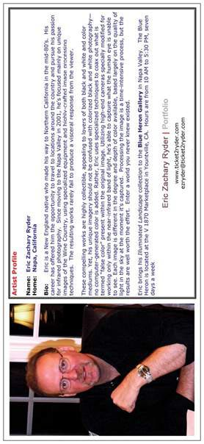

Certificate of Authentication

If you want to sell for top dollar, you have to give the buyer something they perceive as unique and “special”. Offering your prints in a Limited Edition makes the print potentially more valuable in the future – assuming you ever make the big time. If this is to be possible collector of your work, a Certificate of Authenticity is an important document and adds that sense of exclusivity and pride of ownership. The following is something I use.

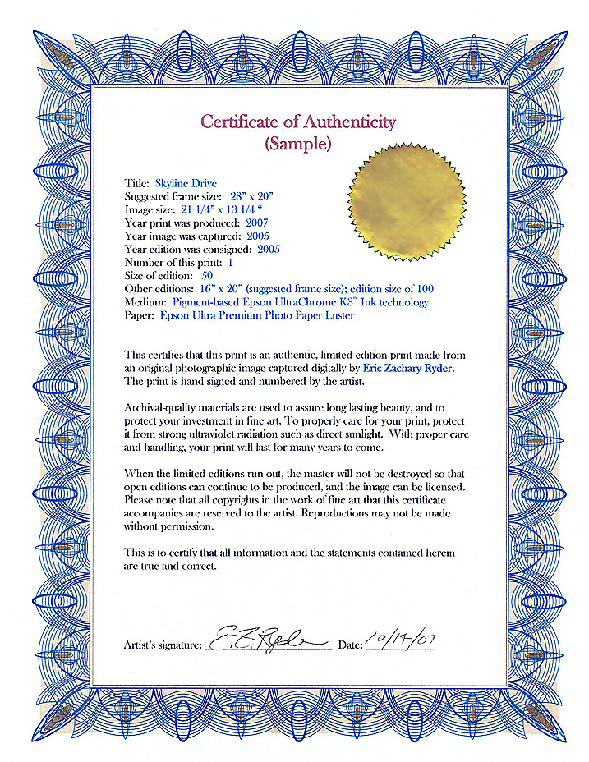

Press Release

Once you join a gallery, you will want to give the owner a press release to give to the local media. The following is a sample showing the pertinent information. It should be informative, but to the point.

FOR IMMEDIATE RELEASE  Eric Zachary Ryder  Infrared Photography | 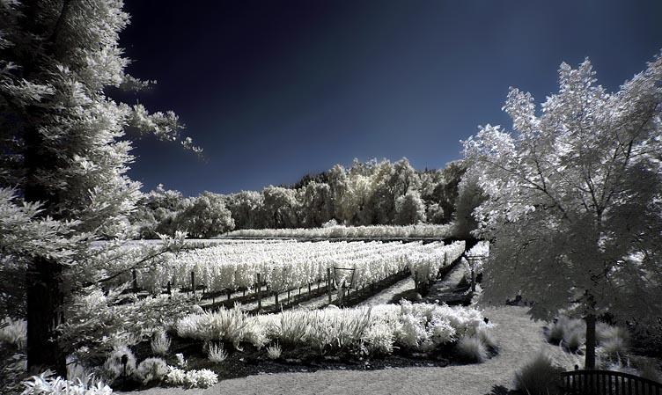

The Blue Heron Gallery is pleased to announce the addition of photographer Eric Zachary Ryder to our gallery in Yountville. Eric specializes in infrared imagery, with color coaxed from the palette of what’s known as “false color” available in the near-infrared light spectrum. His work never fails to produce a visceral reaction in the viewer, due to the dreamscape-like quality of the image.

These works are admired and collected by lovers of both black and white and color mediums. These are not colorized black and white photographs. There is no computer-generated digital “painting” here. The image is processed using specialized techniques to draw out and sometimes modify any color that may be present, but nothing is inherently changed in the image itself.

Images are captured using high-end cameras specially modified for working only within the near-infrared band of the light spectrum. The camera captures what you are unable to see – and lets you see more, while at the same time, seeing less. Each image is different in the degree and depth of color available, based largely on the quality of light in the sky at the moment it's captured, among other factors. Processing the image is a time-intensive process, but the results are worth the effort.

The Blue Heron Gallery is located at the V 1870 Marketplace in Yountville, CA. Hours are 10 AM to 6 PM, seven days a week. There will be a reception for the artist on Sunday, December 17th from 11-12 AM.

Where To Hang

Pricing

Racks

GENERAL TIPS

Transporting Your Work

Bags

Donating Your Work

APPENDIX A

List of Suppliers

